**Homework Assignment 1 (Due Day: Apr. 27, 2017)**

Name: **Princess L Kim** ID: **967760113** email: [prikim@pdx.edu](mailto:prikim@pdx.edu)

Submission Date: **4-27-17** Late Days Used: **0**

Collaboration Acknowledgement: **Chris M. and Eunji/Zoey Lee**

Solutions of 1.1

**The cost is 530,000, so the post-delivery maintenance cost is that multiplied by three, resulting in $1,590,000.**

Solution of 1.6

368/3 = 123

18,900/123 ~= 153.66

**So it would be about $154.**

Solution of 1.7

**18,900 / (368/52) ~= 2,670.**

Solution of 5.1

|  |  |  |  |
| --- | --- | --- | --- |
| Current Transaction | Insert | Modify | Delete |
| Insert | Error | Insert, then mod | n/a |
| Modify | If sorted, not possible | Second mod | Delete record |
| Delete | If sorted, not possible | If sorted, not possible | Error |

Solution of 5.2 – 5.5

-on next page-

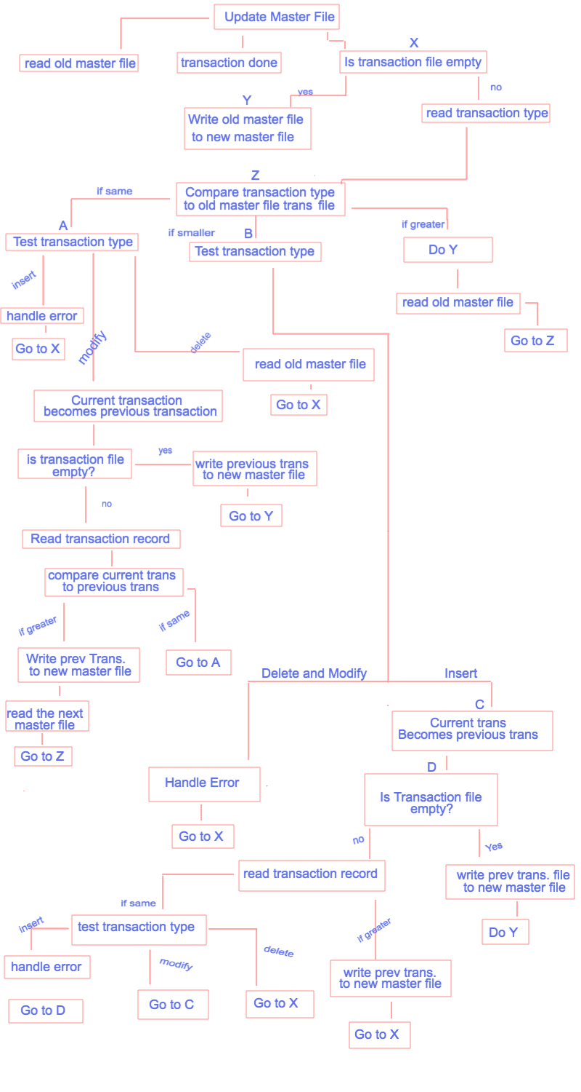

Solution of 11.23

